PRACTICAL - 11

Name: Tasneem Sadikot
PRN: 23070521162
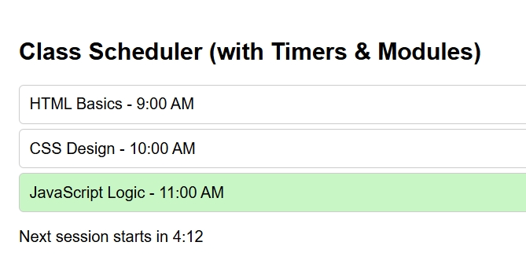
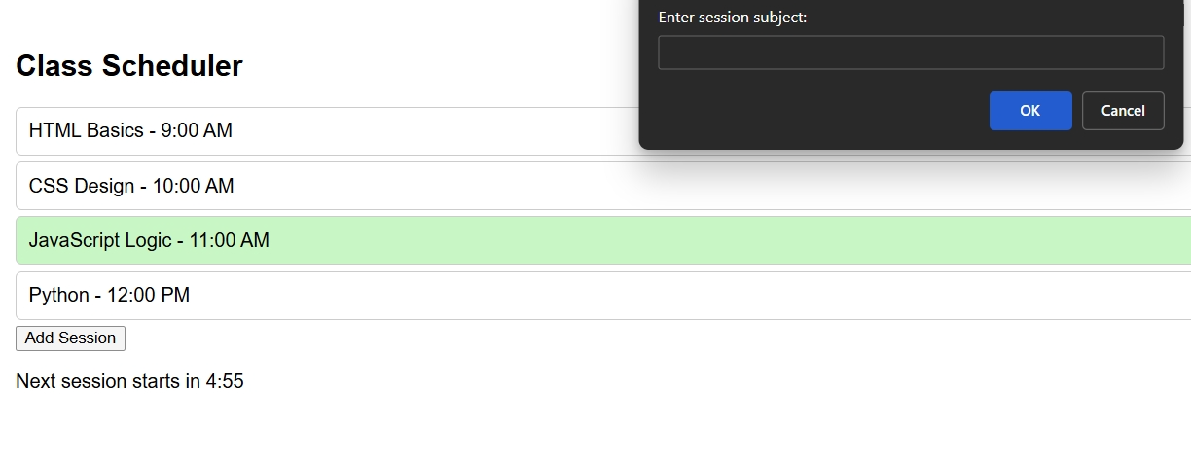
index.html
<!DOCTYPE html>
<html lang="en">
<head>
<meta charset="UTF-8">
<title>Timers, Dynamic UI & Modular Design</title>
<style>
body {
font-family: Arial;
padding: 20px;
}

/* Each class session block */
.session {
padding: 10px;
margin: 5px 0;
border: 1px solid #ccc;
border-radius: 5px;
cursor: pointer;
}

/* Highlight active session */
.active {
background: #c8f7c5;
}

/* Responsive font size */
@media (max-width: 500px) {
body {
font-size: 14px;
}
}
</style>
</head>
<body>
<h2>Class Scheduler </h2>

<!-- Container for all sessions -->
<div id="sessions">
<div class="session" data-time="09:00">HTML Basics - 9:00 AM</div>
<div class="session" data-time="10:00">CSS Design - 10:00 AM</div>
<div class="session" data-time="11:00">JavaScript Logic - 11:00 AM</div>
</div>

<!-- Button to add new session -->
<button id="addSessionBtn">Add Session</button>

<!-- Display countdown timer -->
<p id="countdown"></p>

<script type="module" src="main.js"></script>
</body>
</html>
timer.js
// timer.js — contains countdown and session highlight logic
import { formatTime, logEvent } from './helper.js';

// Function to start a countdown timer
export function startCountdown(duration, display) {
let time = duration;

const timer = setInterval(() => {
const formattedTime = formatTime(time);
display.textContent = `Next session starts in ${formattedTime}`;

// Change color when < 1 minute left
if (time <= 60) {
display.style.color = "red";
} else {
display.style.color = "black";
}

time--;
if (time < 0) {
clearInterval(timer);
display.textContent = "Session Started!";
logEvent("Countdown completed");
}
}, 1000);
}

// Highlight active session
export function highlightActiveSession() {
const sessions = document.querySelectorAll('.session');
const now = new Date();
const currentHour = now.getHours();

sessions.forEach(session => {
const hour = parseInt(session.dataset.time.split(':')[0]);
if (hour === currentHour) {
session.classList.add('active');
} else {
session.classList.remove('active');
}
});
}

helper.js
// helper.js — utility functions

// Format seconds into mm:ss
export function formatTime(seconds) {
const minutes = Math.floor(seconds / 60);
const secs = seconds % 60;
return `${minutes}:${secs < 10 ? '0' + secs : secs}`;
}

// Simple logger
export function logEvent(message) {
console.log(`[LOG]: ${message}`);
}

ui.js
// ui.js — handles UI behavior
import { logEvent } from './helper.js';
import { startCountdown } from './timer.js';

// Responsive background
export function handleViewportChange() {
if (window.innerWidth < 600) {
document.body.style.background = '#f0f8ff';
} else {
document.body.style.background = 'white';
}
}

// Add/edit session functionality
export function addDynamicSessions(countdownDisplay) {
const sessionsDiv = document.getElementById('sessions');
const addBtn = document.getElementById('addSessionBtn');

// Edit existing session
sessionsDiv.addEventListener('click', (e) => {
if (e.target.classList.contains('session')) {
const newSubject = prompt("Enter new subject for this session:", e.target.textContent);
if (newSubject) {
e.target.textContent = newSubject;
logEvent(`Session updated to: ${newSubject}`);
}
}
});

// Add new session dynamically
addBtn.addEventListener('click', () => {
const subject = prompt("Enter session subject:");
const time = prompt("Enter session time (HH:MM, 24hr format):");
if (subject && time) {
const newSession = document.createElement('div');
newSession.className = 'session';
newSession.dataset.time = time;
newSession.textContent = `${subject} - ${time}`;
sessionsDiv.appendChild(newSession);

logEvent(`New session added: ${subject} at ${time}`);
alert("New session added!");

// Automatically start a 2-minute countdown for the new session
startCountdown(120, countdownDisplay);
} else {
alert("Please enter valid subject and time!");
}
});
}

main.js
// main.js
import { startCountdown, highlightActiveSession } from './timer.js';
import { handleViewportChange, addDynamicSessions } from './ui.js';

// Select countdown display
const countdownDisplay = document.getElementById('countdown');

// Start a 5-minute countdown initially
startCountdown(300, countdownDisplay);

// Highlight sessions every minute
setInterval(highlightActiveSession, 60000);
highlightActiveSession();

// Responsive adjustments
window.addEventListener('resize', handleViewportChange);
handleViewportChange();

// Enable session features
addDynamicSessions(countdownDisplay);

